INFLUENTIAL PEOPLE OF THE PROGRESSIVE ERA GROUP PROJECT

Introduction: In a small group you will become an expert on an influential person in the United States during the Progressive Era. You will then take that knowledge and present your person to the class. To assist with your presentation, you will create a PowerPoint presentation and a fact sheet to hand-out to your classmates.

Groups: You MUST work in groups of 2-3 for this project. Your group will be assigned the person you will research and present.

Main Topic Questions to Address:
- What were they known for?
- When were they alive and where?
- What were the main accomplishments?
  - Describe some of their works: give examples
  - Analyze the impact of the accomplishments.
- What were the challenges?
  - How did they handle the challenges?
- What were the effects of their work?
- How has history viewed them?
- What was their legacy?

Additionally:
- You will also create a PowerPoint (or Prezi) that will cover specific information from your research. It must contain:
- Your Thesis based on the accomplishments of the person.
- Background information on your person
- Evidence of the thesis that also covers the above questions.
- Conclusion
- Pictures
- References- this is to be added to the last slide. Every source you use must be cited! (50% off if not included. -5 points if not in MLA format)
- You will also create a handout on your person for your classmates. The information should be presented in an informative, but interesting way. This should not simply be the PowerPoint re-typed. Present the information differently!
Grading:
- Hand-out: 20 points
- Presentation and PowerPoint: 25 points
- Total: 45 x 2= 90 Points

PROGRESSIVE ERA GROUP PROJECT RUBRICS

I. Handout Rubric: ____/20 points
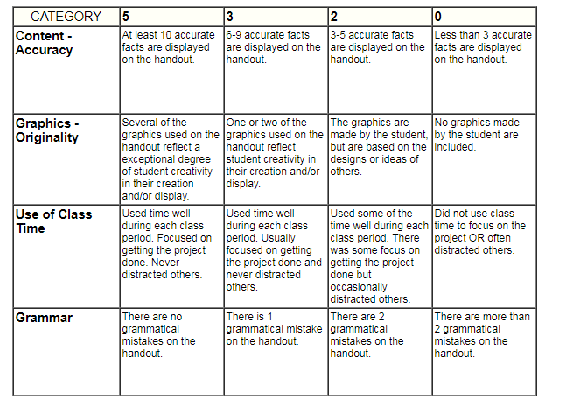

II. Presentation/PowerPoint Rubric: ____/25 points
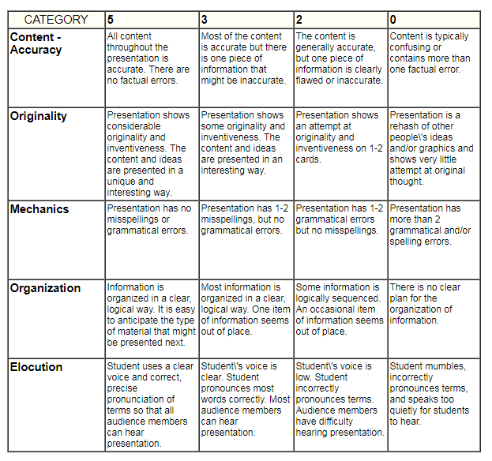 Total: _____/90 Points

