Great Depression/WWII POP Figure Assignment
Directions:
- Pick one main person from the list below to research in order to create your Pop figure.
- Character Biography- This should be in your own words and include the major achievements of your person and their impact on the Renaissance - should be 6-8 sentences. You will need to cite your sources on the back of your paper! If you do not cite your sources, you will lose 50% credit.
- Accessories - must have at least three that are logical and relevant to that character
- “Collect them all!” - you can have some people that don’t necessarily have names, but are relevant to this person in their corresponding empire (a caption for them is required)
- Must have color and be historically accurate. Include what “series” would contain your Pop figure.
Choices:

- Herbert Hoover
- Franklin D. Roosevelt
- Adolf Hitler
- Winston Churchill
- Harry S. Truman
- Joseph Stalin
- Hirohito
- Tojo
- Benito Mussolini
- Dwight D. Eisenhower
- George Patton
- Douglas MacArthur
- General Erwin Rommel

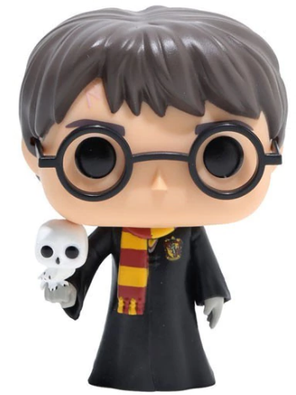

Rubric
 | 7 Points | 5 Points | 3 Points | 0-1 Points
Pop Figure | All graphics are related to the figure and make it easier to understand. | All graphics are related to the figure and most make it easier to understand. | Most graphics relate to the figure. | Graphics do not relate to the figure
Character Biography | Information clearly relates to the main topic. It includes several supporting details and/or examples. | Information clearly relates to the main topic. It provides 1-2 supporting details and/or examples. | Information clearly relates to the main topic. No details and/or examples are given. | Information has little or nothing to do with the main topic.
Series | Series name is included and relevant | Series name is included and semi-relevant | Series name is included and not relevant | Series name is not included
Character Name | Character name is included |  |  | Character name is missing
“Collect Them All” | Each figure in the series is related to the Pop figure and includes a caption | Most figures in the series are related to the Pop figure and includes a caption | Some figure in the series are related to the Pop figure and but some captions are missing | Each figure in the series is either not related to the Pop figure and/or doesn’t include a caption
Accessories | All accessories are related to the figure and make it easier to understand. | All accessories are related to the figure and most make it easier to understand. | Most accessories relate to the figure. | Accessories do not relate to the figure

